**HOPE ARTIFICIAL INTELLIGENCE**

**Univariate Central Tendency:**

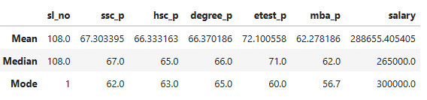

***Brief details given below about the above table***

* **Mean - We come to know from the above table, all Students high school(67.30),higher secondary school(66.33,degree(66.37) and mba (62.27)average marks scored whereas in entrance test(72.10) scored good marks.Hence their average salary will be approximately Rs.288655.405405.**
* **Median – There seems to be outliers, so the values are 67, 65,66,71,62 & 265000 respectively.**
* **Mode – The repeated values are 62,63,65,60,56.7 & 300000 respectively.**